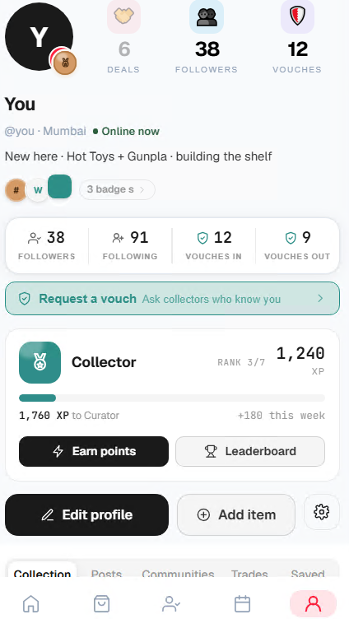
#3 collector is still showing

Remove this 3/7?
Same badges twice?
The green is? Seems it has not created a badge for Rank Badg

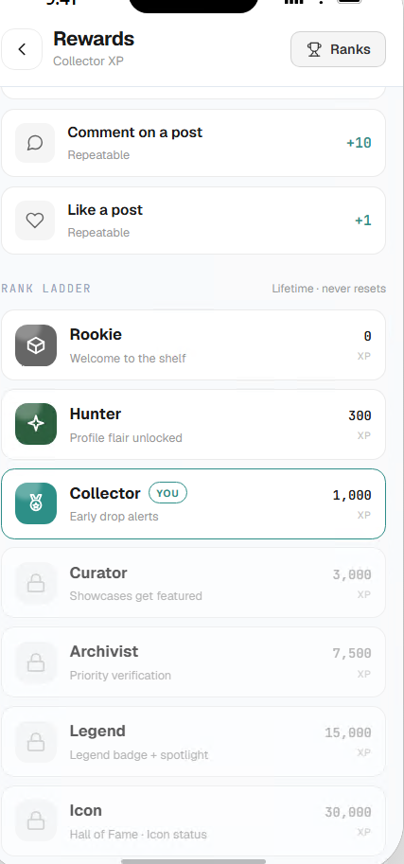
Remove the benefits?

